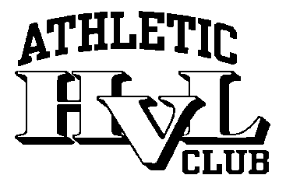

HVLAC PARENTS CODE OF CONDUCT

- I hereby pledge to provide positive support, care and encouragement for my child participating in youth sports by following the HVLAC (Hidden Valley Athletic Club) Parents Code of Conduct.
- I will encourage good sportsmanship by demonstrating positive support for all players, coaches, and officials at every game, practice or event.
- I will place the emotional and physical well-being of my child and other children ahead of my own personal desire to win.
- I will support coaches and officials working with my child, in order to encourage a positive and enjoyable experience for all.
- I will ask my child to treat other players, coaches, fans and officials with respect regardless of race, sex, creed or ability and will do so myself.
- I will refrain and see to it that my child refrain from verbally or physically threatening or assaulting any club member or participant to include a coach, player, umpire, parent, or member-at-large.
- I will not engage and see to it that my child will not engage in fighting, incite a fight, use profanity, steal, vandalize, threaten and or intimidate others.
- I will refrain from the use of and being under the influence of, drugs and alcohol during youth sporting events associated with HVLAC.

If I should breach this code of conduct, I will respect and abide by the consequences of my actions.

Consequences of not abiding by the HVL Parents Code of Conduct
- 1st offense: Verbal Warning that will be noted and reported at the regularly scheduled HVLAC meeting following the incident.

- 2nd offense: One week suspension from practice and games (parent/guardian only) (You are expected to bring your child to practice and games but are banned from the immediate practice or game area. Incident will be reported at following HVLAC meeting.

- 3rd offense: Permanent ban from games and practices through the end of the season. Incident to be reported and documented at HVLAC meeting.

